19.61: a) For as isothermal process for an ideal gas, b) For an adiabatic process, Q = 0, and 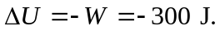 c) For isobaric, 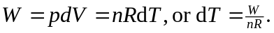 Then, 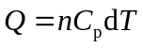 and substituting for dT gives Substituting for 